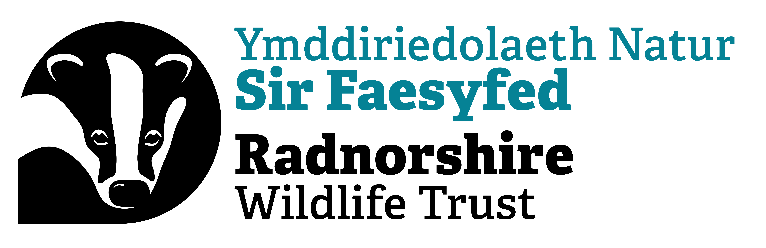
Radnorshire Rivers
Intern
Job Description

IDENTIFICATION OF JOB

Working base Warwick House, Llandrindod Wells (with occasional travel within England and Wales)
Fixed-term Contract Hybrid contract
Duration: 9 months
Responsible to: Project Manager
Salary: £20,000
Holiday Entitlement: 25 days per annum plus Bank Holidays
Pension: Enrolment into the NEST auto-enrolment scheme, currently with 3% minimum employees’ contribution with a 6% contribution from RWT.
Working Hours: 37 hours per week, with flexible working arrangements. Some evening and weekend work required for which Time Off In Lieu will be awarded.

Overall Purpose of the role:

The Radnorshire Rivers project aims to restore and reconnect Radnorshire’s riparian habits strengthening their role as vital corridors for wildlife. Working with local farmers and landowners, this project will evidence both the need and the success for a change in land management use, specifically within 3 identified priority zones along key Radnorshire rivers.
This will be achieved through practical interventions on identified sites, building strong relationships with local landowners through proven results and outreach, as well as surveying of protected sites. This project will produce information in the form of detailed maps that will form the basis for wider ecological work and feed into the development of a Resilient Ecological Network.
This internship is an exciting opportunity for someone interested in getting into conservation work. The job will be focused on providing training and hands on experience. Through this role you will get the opportunity to work with the community & directly deliver ecological interventions.
Main Duties & Responsibilities
Your responsibilities will include but are not limited to:
- Undertake and support practical habitat restoration and management interventions
- Organising presentations, workshops and events where you will act as a representative of RWT
- Working with a range of landowners, land managers and colleagues to identify the best locations and types of habitat creation and management to help nature’s recovery.
- Producing detailed maps and surveying land & protected sites.

PERSON SPECIFICATIONS
Skills and abilities

Travel is an essential part of this role, so a full and valid driving licence and own car, insured for business use is required.

Desirable Environmental skills:

Any applicants must have proven experience or knowledge about environmental roles. We are looking for someone passionate about nature’s recovery who wants to build upon their skills with practical experience.

- A degree qualification or equivalent practical experience in environmental sciences/agriculture/conservation management or similar. Equivalent relevant experience will be considered as highly as academic qualifications.
- Experience with GIS or other equivalent mapping tools
- Commitment to nature conservation
- Good natural history skills

Other Essential skills include:

                - Experience using IT software including email, MS Word, PowerPoint, Excel and videoconference apps.
                - Any applicant must have at least a base knowledge of the pronunciation of Welsh place names

Other desirable skills:

- Ability to communicate in the Welsh language
- Practical land management skills, backed by certification e.g. chainsaw certificate, tractor, ATV and off road driving skills, brushcutter etc

RWT is looking for someone who is committed to nature and communicating this to a wider audience, someone who is good natured and able to communicate effectively and clearly to a broad audience, some of whom may have dissenting opinions. Above all it is important that any applicant be respectful of community members.

